Mouton Rothschild Vertical Tasting – 22 May 2025 - Start 18:30

9299 kr per person

First Tasting– Mouton Rothschild 1997 and 1995

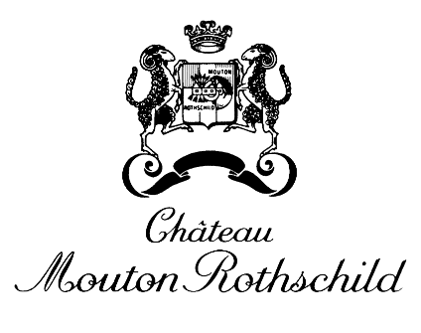
Smoked duck breast, duck leg croquette, plum purée

Second Tasting – Mouton Rothschild 1992

Pearl barley risotto, fresh peas, roasted morel

Third Tasting– Mouton Rothschild 1983 and 1982
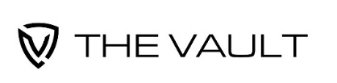
Pigeon breast, ramsons, grilled asparagus, pigeon sauce

Fourth Tasting – Mouton Rothschild 1981 and 1978

A selection of aged cheeses

