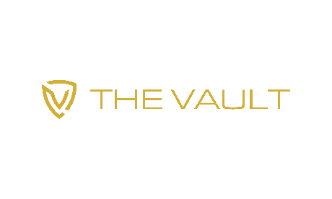
Job Description – The Vault - Sommelier – Full time

The Vault – a private wine club and wine storage facility - is opening in February 2022 at Hauser Plads 32 in the center of Copenhagen. We are looking for a full time Sommelier to be part of our opening team! As part of our team you will have the opportunity to work with other highly qualified Sommeliers, such as Eros Teboni – who was declared World’s Best Sommelier in 2018. (www.erosteboni.com)
This is a unique opportunity to serve some of the most prestigious wines available, to some of the most discerning wine drinkers in Denmark. It’s sure to be an experience that you can’t get as a sommelier anywhere else. If you join us, you will become part of the initial team that sets the service standards for Copenhagen’s first private wine club.
Our first priority is to employ someone that has a ton of knowledge about wine. However, its equally important that you can complement that knowledge with a great personality and impeccable serving skills. Therefore you must be a trained sommelier
Your duties will include things such as:
- Opening, decanting, and serving wine to our Wine Club customers
- Giving our customers a broad overview of the wine(s) you are serving, including things such as the history of the producer and the flavors and characteristics of the wine.
- Ensuring a high level of customer satisfaction; giving attentive service
- Receiving and registering wines that are delivered for storage; preparing wines that are ordered or opening
- Joint responsibility for the opening and closing of the wine club each evening
- Contributing ideas to the owners to increase revenue
The job will start at the end of January for some training, and full time employment will start in February.
Job Requirements:
- You must be an educated Sommelier with at least 2 years of experience; work experience in a higher end / Michelin restaurant is a plus.
- Great English language skills: Danish language skills is a plus
- A super friendly and extrovert personality – you find joy in talking to customers
Salary and compensation with be based on your experience and can be discussed during the interview.
Email your application and salary expectation range to sommelier@thewinevault.dk. Check out our website at www.thewinevault.dk to learn more about our concept.

